**Assignment 4**

**1001575625**

**Neerja Narayanappa**

**1. Draw a Structural Graph that represents the below piece of source code.**

**You must indicate how each node and edge corresponds to the code.**

**Then, find the test paths (First you need to find all the prime paths and then you can create the test paths from them)**

**int count_spaces(char∗ str)**

**{**

**int length, i , count;**

**count = 0;**

**length = strlen(str );**

**for (i=1; i<length; i++) {**

**if(str[i] == ’ ’) {**

**count++;**

**}**

**}**

**}**

**Solution:**

Structural Graph:

count = 0;

length = strlen(str );

i = 1

i < length

i++

Count++

str[i] == ’’

str[i] != ’ ’

i >= length

return(count)

Node Coverage:

Test Requirements = {1, 2, 3, 4, 5, 6, 7}

Test path = [1, 2, 3, 4, 5, 6, 3, 7]

**2. Consider the following fragment of code:**

**public int foobar(int x, int y,int z) {**

**int k = 0;**

**for(int i=0; i < z; i++)**

**{**

**for(int j=0; j<y; j++)**

**{**

**if(i<j) {**

**k=k*y+x;**

**}**

**else {**

**k--;**

**}**

**}**

**}**

**return(k);**

**}**

**Solution:**

**a) Draw a structural control flow graph that represents the above piece of source code. (5 pts.)**

k = 0

i = 0

i >= z

i < z

j = 0

j >= y

j < y

i ++

i < j

i >= j

k - -

k=k*y+x

y++

**b) For you graph, enumerate a complete set of paths that guarantee node coverage. (5 pts.)**

Node Coverage:

Test Requirements = {1, 2, 3, 4, 5, 6, 7}

Test path = [1, 2, 3, 5, 6, 8,10, 5, 7, 2, 4], [1,2,3,5,6,9,10,5,7,2,4]

**c) Construct a finite set of test cases that guarantee node coverage. For each test case indicate which execution path is covered. (5 pts.)**

If the conditions i < z & i<j $ j <y satisfy,

ie, Test case: {i = 10 , z =20, j = 15 ,y =19}

Then the nodes covered are: = [1, 2, 3, 5, 6, 8,10, 5, 7, 2, 4]

If the conditions i < z & i>=j $ j <y satisfy,

ie, Test case: {i = 10 , z =20, j = 5 , y =12}

Then the nodes covered are: = [1, 2, 3, 5, 6, 9,10, 5, 7, 2, 4]

**d) For the above fragment of code is there any difference in requiring complete edge coverage rather than node coverage? Justify your answer. (5 pts.)**

Yes, complete edge coverage is required since by using only node coverage all the nodes cannot be visited at once as seen in Q(a).

Therefore, It would definitely make a difference.

**e) Enumerate all the prime paths of the graph you have constructed. (5 pts.)**

Length 0

[1]

[2]

[3]

[4] !

[5]

[6]

[7]

[8]

[9]

[10]

Length 1

[1,2]

[2,3]

[2,4] !

[3,5]

[5,6]

[5,7]

[6,8]

[6,9]

[8,10]

[9,10]

[10,5]

[7,2]

Length 3

[1,2,4] !

[1,2,3]

[2,3,5]

[3,5,6]

[3,5,7]

[5,7,2]

[7,2,4] !

[5,6,8]

[5,6,9]

[6,8,10]

[6,9,10]

[8,10,5]

[9,10,5]

Length 4

[1,2,3,5]

[2,3,5,6]

[2,3,5,7]

[3,5,6,8]

[3,5,6,9]

[3,5,7,2]

[5,7,2,4] !

[5,6,8,10]

[5,6,9,10]

[6,8,10,5]

[6,9,10,5]

[8,10,5,7]

[9,10,5,7]

[10,5,7,2]

**Prime Paths :**

1. [1,2,4]

2. [1,2,3,5,6,8,10,5,7,2,4]

3. [1,2,3,5,6,9,10,5,7,2,4]

4. [1,2,3,5,7,2,4]

**f) For each prime path that you have found construct a test case for that path. Indicate which prime path is covered by your test cases. (5 pts.)**

1. Prime Path: {1,2,4}

Test case must satisfy the condition i >= z

Test case for the path is {i = 20, z =10} or { i =20, z=20}

2. Prime Path: {1,2,3,5,6,8,10,5,7,2,4}

Test Case must satisfy the conditions i < z & i<j $ j <y

Test case for the path is {i = 10, z =20, j = 15, y =19}

3. Prime Path: {1, 2, 3, 5, 6, 9,10, 5, 7, 2, 4}

Test Case must satisfy the conditions i < z & i>=j $ j <y

Test case for the path is: {i = 10 , z =20, j = 5 , y =12}

4. Prime Path : {1,2,3,5,2,4}

Test Case must satisfy the conditions i < z & j >= y

Test case for the path is: {i = 10, z = 20 , j = 25, y= 15}

**3. Below are four graphs, each of which is defined by the sets of nodes, initial nodes, final nodes, edges, and defs and uses. Each graph also contains a collection of test paths. Answer the following questions about each graph (12 points for each graph – Total 48 pts.)**

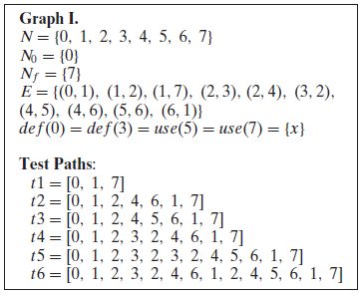

**Solution:**

**a) Draw the graph.**

use(x)

Def(x)

Def(x)

use(x)

**b) List all of the du-paths with respect to x. (Note: Include all du-paths, even those that are sub-paths of some other du-path).**

The du-paths with respect to x are as follows:

(0,1,7)

(3,2,4,5)

(0,1,2,4,5)

(3, 2, 4, 5, 6, 1, 7)(not required if the note is not mentioned)

(3, 2, 4, 6, 1, 7)

**c) For each test path, determine which du-paths that test path tours.For this part of the exercise, you should consider both direct touring and side-trips.**

**Hint: A table is a convenient format for describing this relationship.**

|  |  |  |
| --- | --- | --- |
|  | Direct touring | Side-trips |
| T1 | (0,1,7) |  |
| T2 |  | (0,1,7) |
| T3 | (0,1,2,4,5) | (0,1,7) |
| T4 | (3, 2, 4, 6, 1, 7) | (0,1,7) |
| T5 | (3,2,4,5), (3, 2, 4, 5, 6, 1, 7) | (0,1,7), (0,1,2,4,5) |
| T6 |  | (0,1,7)  (3,2,4,5)  (0,1,2,4,5)  (3, 2, 4, 5, 6, 1, 7)  (3, 2, 4, 6, 1, 7) |

**d) List a minimal test set that satisfies all-defs coverage with respect to x. (Direct tours only.) Use the given test paths.**

Minimal test set that satisfies the above conditions are

{T1, T5} or

{T3, T4} or

{T3, T5} or

{T1, T4}

**e) List a minimal test set that satisfies all-uses coverage with respect to x. (Direct tours only.) Use the given test paths.**

Minimal test set that satisfies the above conditions are

{T1, T3, T5}

**f) List a minimal test set that satisfies all-du-paths coverage with respect to x. (Direct tours only.) Use the given test paths.**

Minimal test set that satisfies the above conditions are

{T1, T3, T4, T5}

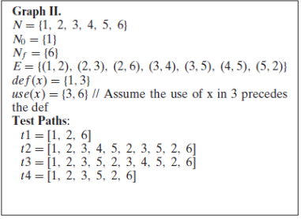

**Solution:**

**a)  Draw the graph.**

Def(x)

use(x)

Def(x)

use(x)

**b)  List all of the du-paths with respect to x. (Note: Include all du-paths, even those that are sub-paths of some other du-path).**

The du-paths with respect to x are as follows:

(1,2,3)

(1,2,6)

(3,5,2,6)

(3,5,2,3)

(3,4,5,2,3)

(3,4,5,2,6)

**c)  For each test path, determine which du-paths that test path tours. For this part of the exercise, you should consider both direct touring and side-trips.  
*Hint: A table is a convenient format for describing this relationship***

|  |  |  |
| --- | --- | --- |
|  | Direct touring | Side-trips |
| T1 | (1,2,6) |  |
| T2 | (1,2,3), (3,5,2,6), (3,4,5,2,3) |  |
| T3 | (1,2,3), (3,5,2,3), (3,4,5,2,6) |  |
| T4 | (1,2,3), (3,4,5,2,6) |  |

**d)  List a minimal test set that satisfies all-defs coverage with respect to x. (Direct tours only.) Use the given test paths.**

Minimal test set that satisfies the above conditions are

{T4} or

{T2} or

{T3}

**e)  List a minimal test set that satisfies all-uses coverage with respect to x. (Direct tours only.) Use the given test paths.**

Minimal test set that satisfies the above conditions are

{T1, T2} or

{T1, T3}

**f)  List a minimal test set that satisfies all-du-paths coverage with respect to x. (Direct tours only.) Use the given test paths.**

Minimal test set that satisfies the above conditions are

{T1, T2, T3}

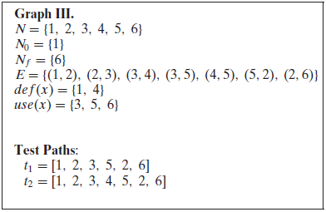

**Solution:**

**a)  Draw the graph.**

use(x)

Def(x)

def(x)

use(x)

use(x)

**b)  List all of the du-paths with respect to x. (Note: Include all du-paths, even those that are sub-paths of some other du-path).**

The du-paths with respect to x are as follows:

(1,2,3)

(1,2,3,5)

(4,5)

(1,2,6)

(4,5,2,6)

(4,5,2,3)

**c)  For each test path, determine which du-paths that test path tours. For this part of the exercise, you should consider both direct touring and side-trips.  
*Hint: A table is a convenient format for describing this relationship***

|  |  |  |
| --- | --- | --- |
|  | Direct touring | Side-trips |
| T1 | (1,2,3), (1,2,3,5) | (1,2,6) |
| T2 | (1,2,3), (4,5), (4,5,2,6) |  |

**d)  List a minimal test set that satisfies all-defs coverage with respect to x. (Direct tours only.) Use the given test paths.**

Minimal test set that satisfies the above conditions are

{T2}

**e)  List a minimal test set that satisfies all-uses coverage with respect to x. (Direct tours only.) Use the given test paths.**

Since no test cases given satisfies the given condition there are has no such test set.

**f)  List a minimal test set that satisfies all-du-paths coverage with respect to x. (Direct tours only.) Use the given test paths.**

Minimal test set that satisfies the above conditions are ( T1, T2}

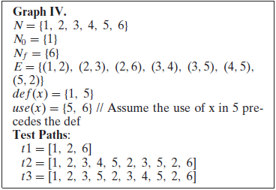

**Solution:**

**a)  Draw the graph.**

def(x)

use(x)

Def(x)

use(x)

**b)  List all of the du-paths with respect to x. (Note: Include all du-paths, even those that are sub-paths of some other du-path).**

The du-paths with respect to x are as follows:

(1,2,3,5)

(1,2,3,4,5)

(1,2,6)

(5,2,6)

(5,2,3,5)

(5,2,3,4,5)

**c)  For each test path, determine which du-paths that test path tours. For this part of the exercise, you should consider both direct touring and side-trips.  
*Hint: A table is a convenient format for describing this relationship.***

|  |  |  |
| --- | --- | --- |
|  | Direct touring | Side-trips |
| T1 | (1,2,6) |  |
| T2 | (1,2,3,4,5), (5,2,3,5), (5,2,6) |  |
| T3 | (1,2,3,5), (5,2,6), (5,2,3,4,5) |  |

**d)  List a minimal test set that satisfies all-defs coverage with respect to x. (Direct tours only.) Use the given test paths.**

Minimal test set that satisfies the above conditions are

{T2} or

{T3}

**e)  List a minimal test set that satisfies all-uses coverage with respect to x. (Direct tours only.) Use the given test paths.**

Minimal test set that satisfies the above conditions are

{T1, T3} or

{T1, T2}

**f)  List a minimal test set that satisfies all-du-paths coverage with respect to x. (Direct tours only.) Use the given test paths.**

Minimal test set that satisfies the above conditions are

{T1, T2, T3}

**4.** (**15pts.**)Use the following program fragment for questions a-e below.

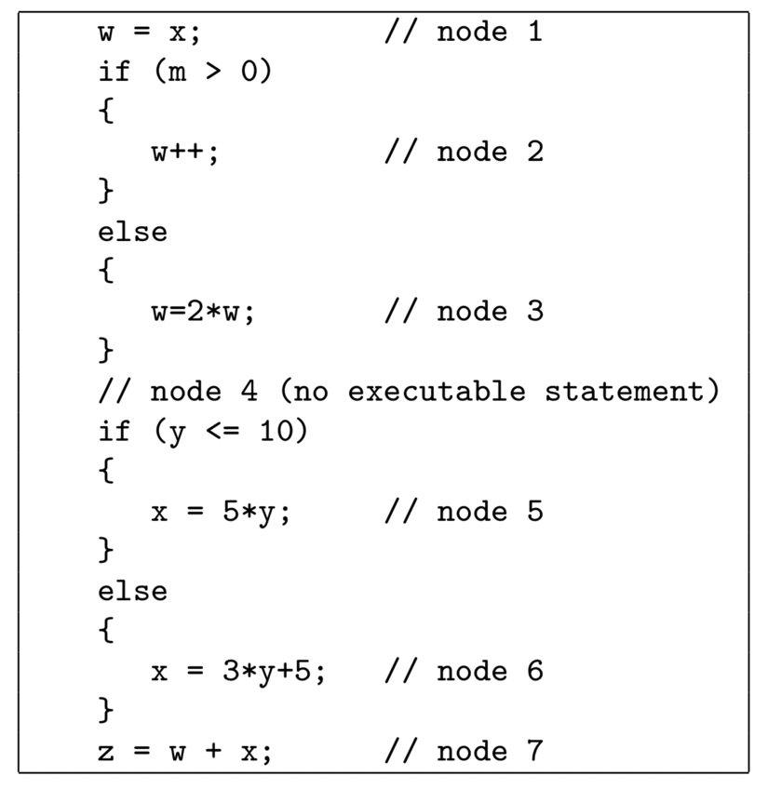

**Solution:**

**a)  Draw a control flow graph for this program fragment. Use the node numbers given above.**

w = x

m > 0

m < =0

w = 2 * w

w++

y > 10

y < =10

x = 3*y + 5

x = 5 * y

z = w + x

**b)  Which nodes have defs for variable w?**

def(w) = {1,2,3}

**c)  Which nodes have uses for variable w?**

use(w) = {2, 3, 7}

**d)  Are there any du-paths with respect to variable w from node 1 to node 7? If not, explain why not. If any exist, show one.**

No def-clear paths. Hence there is no du-paths from 1 to 7

**e)  Enumerate all of the du-paths for variables w and x.**

du-paths for w

[1,2]

[1,3]

[2,4,6,7]

[2,4,5,7]

[3,4,6,7]

[3,4,5,7]

du-paths for x

[5,7]

[6,7]

===============================END==================================